**Design Document for Children’s Game; The Witch and The Potions**

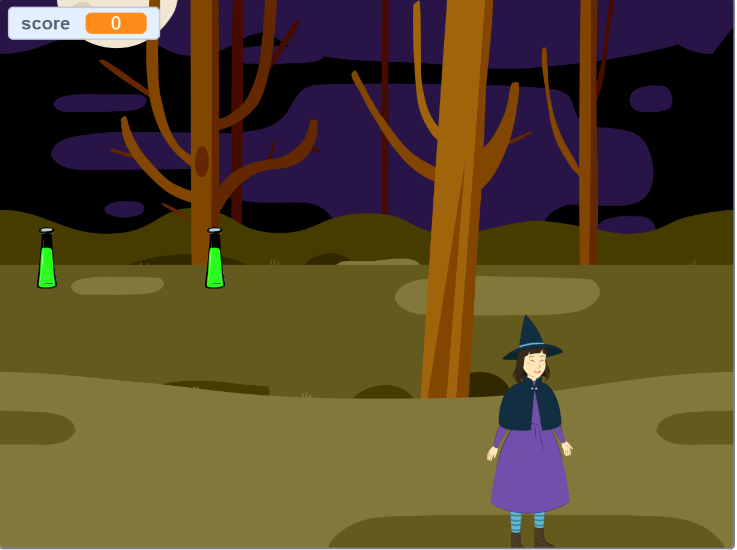

**Overview of the Project and the Title**:

The title of the game is The Witch and The Potions

This is a game created using Scratch about a witch catching potions that are falling from the sky. Her mission is to move right and left and catch as many potions as she can. As soon as the witch touches a potion, a cheering sound is made, and 1 point is added to her score. The score is calculated with the number of potions caught, when score is more than 15, the game ends, “You Win!” background appears, and a cheering sound is made.

**Key Stakeholders**:

Children playing the game, the witch, the potions, “You Win” background that shows at the end

**Purpose of the Project and Goals:**

The purpose of the game is to entertain the kids whilst improving their multi-tasking skills and fine-motor skills whilst using computer and keyboard functions. Rewards(score) are given as they find potions.

**Proposed Solution:**

|  |  |  |
| --- | --- | --- |
| **Witch** | **Potion** | **“You Win”** |
| When the green flag is pressed (start the game) | When the green flag is pressed (start the game) | Go to centre of the screen (position x=0, y=0) and hide |
| Forever move right or left to catch the falling potions | Forever go to random positions and gradually fall (change y by –5). When you touch the ground (y position is less than –170) forever go to the top (set y to 180) | hide |
| When you touch a potion, go to the next one | When wizard touches you, increase score 1 point, a “magic spell” sound is played. Then set y position to 180 (go to the top of the screen and go to a random position | hide |
| When you catch more than 15 potions, game ends, stop | Stop | Show and A “cheer” sound is played |

**Witch’s Flow Chart**

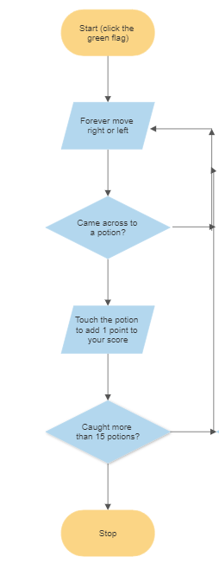

Gokce Gercek

Student No: 19141321